The Heart of Coaching in London: An Analysis of the Existing Workforce

Lorna Leach
London Sport Relationship Management Team
info@londonsport.org

London Sport
190 Great Dover Street
Southwark
London
SE1 4YB

Contents

Section 1: Introduction 3
Headline Information 4
Section 2: Scope of the Research 5
Considered Data 5
Section 3: About the Coaches (Demographics) 6
Section 4: The Coaching Role 7
Employment and Commitment 7
Age and Coaching 8
Route into Coaching 8
Why do coaches coach? 9
Section 5: What, Where and Who do Coaches Coach? 10
What’s being delivered in London? 10
Where does coaching happen? 10
What type of sessions are coaches delivering? 10
Who is getting coached? 11
Section 6: Growth of Delivery, Motivating People to Stay in Coaching 14
Motivating people to stay in coaching 14
Section 7: Training and Development 16
Qualification pathway 16
Continued Professional Development 16
How supported do coaches feel? 17
Section 8: Recommendations 18

Section 1: Introduction
The following report aims to provide a picture of the current workforce behind delivery of physical activity and sport in London. It is based on data collected by London Sport between September and December 2016. The survey was aligned to the work undertaken by Sports Coach UK for the 2015 Coaching Statistics and Analysis report to allow a national comparison. Reference is made to Coaching in an active nation, the Sport England strategy for coaching 2017-2021 and the London Sport Blueprint for A Physically Active City.

Headline Information
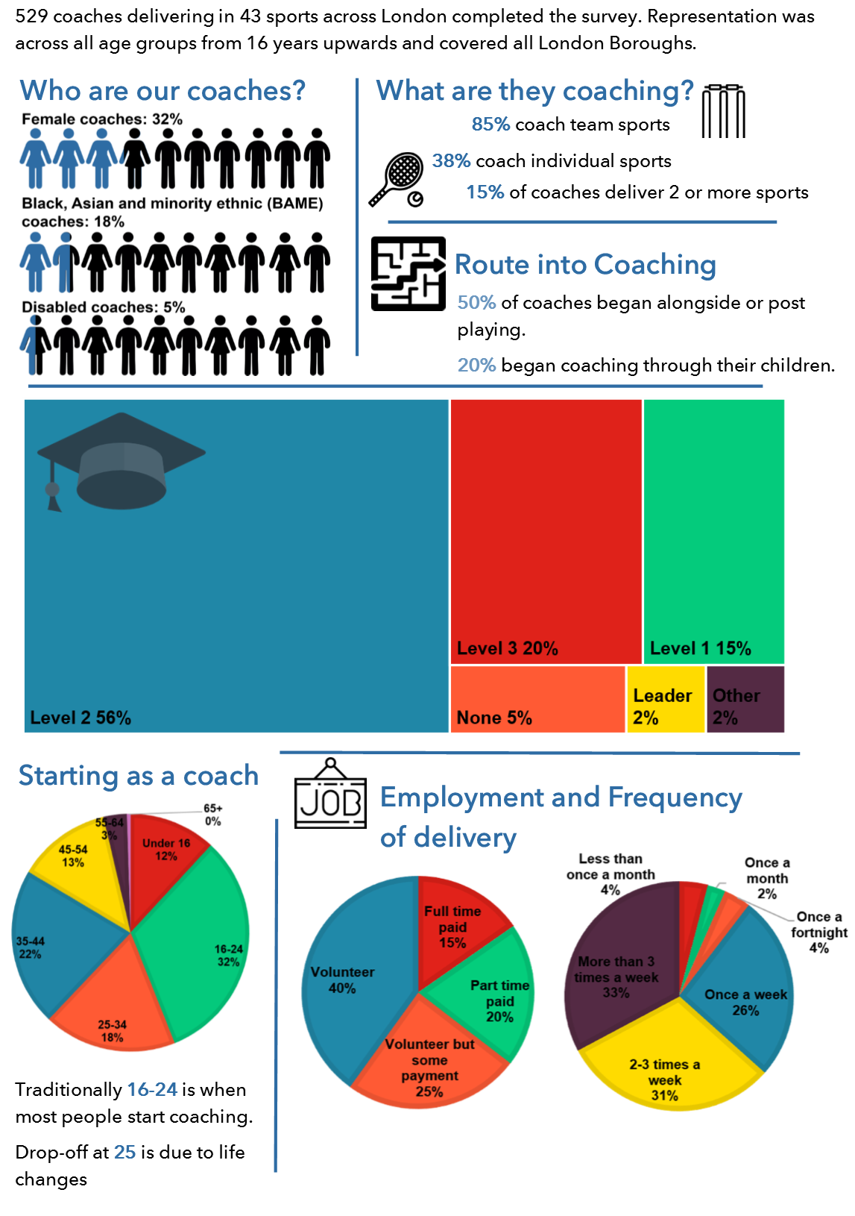

Section 2: Scope of the Research

529 coaches completed the survey across 43 sports. This covered all age groups from under 18 to over 65 years. Responses came from residents in all London boroughs with only 4 having less than 20 responses. The research covers those delivering across the full spectrum from grassroots to elite level activity, responses came from coaches holding no formal sports qualification and those within the qualification pathway. Although the research incorporates a variety of delivery roles (instructors, teachers, coaches, activators and leaders) for the sake of ease all roles were defined under the ‘umbrella coach’ title.

Considered Data

Data on the lives of coaches across London and the national context was considered from the following sources:
- Survey responses
- UK Coaching (previously Sports Coach UK) data

Section 3: About the Coaches (Demographics)
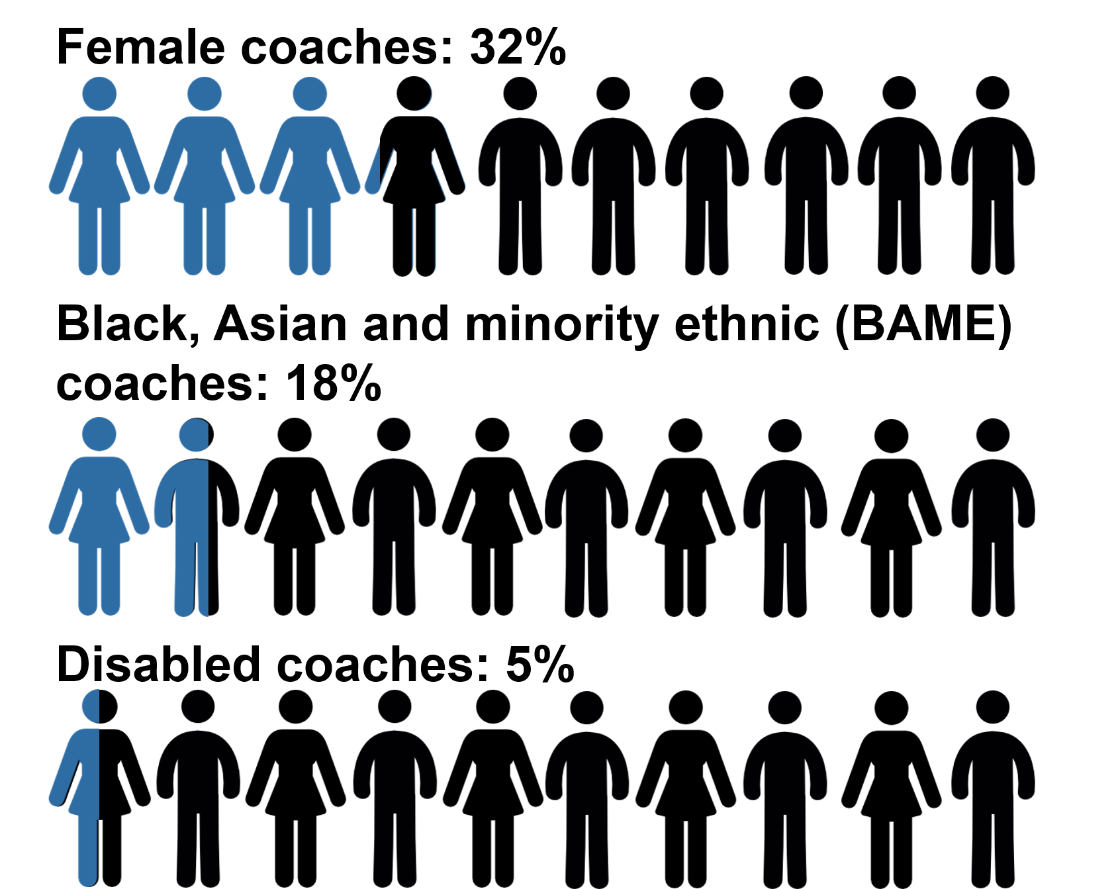
Over the years, national data has identified that coaches are traditionally male, white and non-disabled. Whilst London doesn’t buck the trend there are some differences to national data.

Female Coaches
London has a higher percentage of women in coaching (32% compared to 28% nationally).

Fig 1: Demographics

Black, Asian and Minority Ethnic (BAME) coaches
Although London has a higher percentage of coaches from BAME backgrounds (18% compared to 8% nationally) this correlates with the general ethnic population breakdown of London, where there is a higher than national percentage of residents categorised as BAME (40.6% compared to 18.1% nationally).

Disabled coaches
London shows a slight lower proportion of sports coaches with a disability (5% compared to 6% nationally). Responses were consistent across the 4 categories (physical, learning, sensory and medical).

Coaching in an Active Nation aims to make it easier for people, especially those from under-represented groups, to become coaches.

Section 4: The Coaching Role

In London, 65% of coaches are volunteers (compared to 80% nationally), with 40% taking no payment at all and 25% taking payment in some circumstances.
15% of London coaches are full-time paid, which is 5% higher than their national counterparts (10%).

57% of coaches also have at least one additional voluntary role within sport. 41% have one additional role, 20% have two roles and 39% have three or more voluntary roles. The majority have an administration role e.g. club secretary, chairman or treasurer, with event organiser and officiating roles also being held by over a third of coaches.
Fig 2: Employment
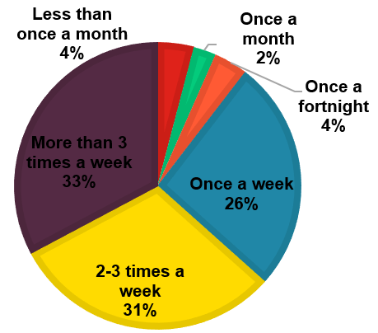

Employment and Commitment
With full-time coaches coaching over 30 hours per week, the remaining categories of coach are focused around two segments (voluntary or paid).
- Volunteers (unpaid) are most likely to coach once a week, followed by 2-3 times a week.
- Volunteer (partially paid) coach 2-3 times a week.
- Paid, part-time coaches are more likely to coach more than 3 times a week, with 2-3 times a week a close second.
Fig 3: Coaching Frequency

According to Sports Coach UK data, London has approximately 300,000* sports coaches. Using the London Sport breakdown for coaching frequency, 15% of coaches are full-time (delivering 30 hours of coaching per week) this is the equivalent of 45,000 coaches in London (*extrapolated data from 2015/16 Coaching Panel).

Age and Coaching
National data has identified that there are two peak entry periods into coaching, these are the 16-24 and 35-44 age groups (Fig 4). London data matches this trend with 31% of respondents entering into coaching between 16 and 24 years of age, and a further 22% starting between 35 and 44 years old. However, in a national comparison, London has a lower percentage in both these age groups, by 3% and 5% respectively. London has a higher percentage of coaches starting at under 16 and in the 45-54 age group. Most of our coaches have been coaching for up to 20 years, with 38% of all the coaches having 10-20 years of coaching experience.
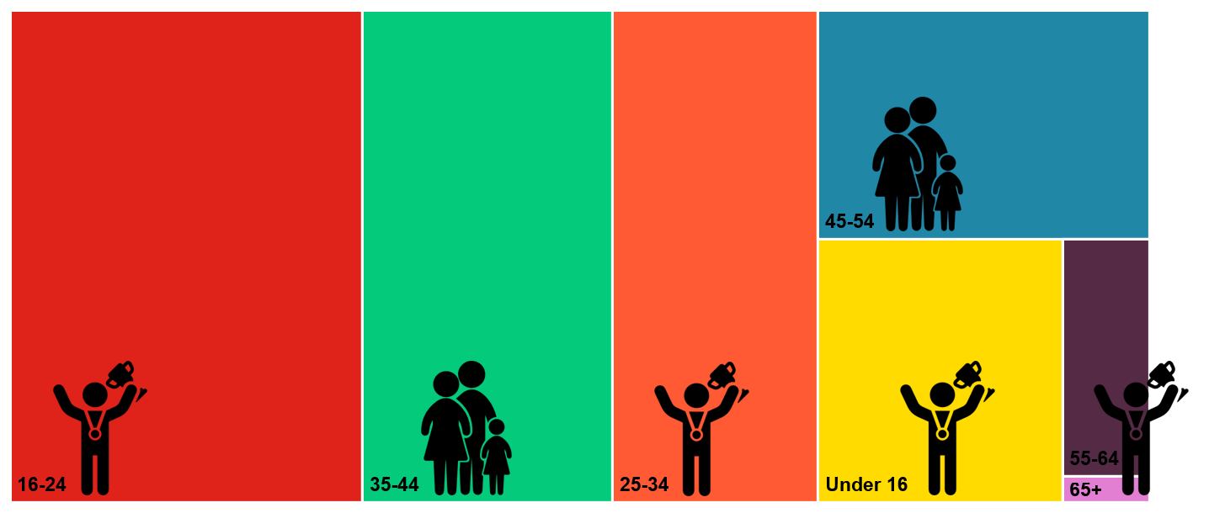
Fig 4: Segment size of coaches by the age they started coaching, overlaid with an image of the most popular route into coaching for that age group.

Route into Coaching
When comparing the age that coaches started coaching to the routes they took into coaching, it can be seen that there is a clear shift from participation route to parent/helper route for 35-54 year olds with 85% of the coaches who started coaching in this age bracket doing so via the parent/helper route.

In line with national data, participation is the main route into coaching with 53% of coaches coming via this route. 19% have started coaching through a parent/helper route (11% nationally). 13% have come into coaching via a volunteering route, also in line with national data.

With more recognition being placed on the softer skills of coaching, we asked the coaches ‘Do you have any other experience that you believe has helped your coaching?’
- 40% coaches felt they had volunteering experience that had helped with their coaching.
- 29% had teaching backgrounds.
- 6% had experience in social work.
A background in policing, also coaching/mentoring through their main employment was credited by several coaches as having given them experiences that helped their coaching.

Why do coaches coach?
In Towards an Active Nation, Sport England outlined the need to recognise the dual benefits that come from volunteers being involved in the act of volunteering. 65% of London’s coaches are working voluntarily, therefore they are a driving force in the delivery of physical activity and sport across the capital. It’s important to recognise the reasons they coach, and ensure that they continue to have access to opportunities that create these experiences.

Coaches were asked to identify the three main reasons why they coach; the results are as follows:

Over 50% of coaches stated:
- Opportunity to help others or a club/team
- Opportunity to develop others

20% to 50% of coaches stated:
- To help a child in their sport
- Social interaction with participants and other coaches
- Opportunity for personal development
- Retain involvement in sport beyond playing days

Less than 20% of coaches stated:
- Provides an income
- Enhances career development

Section 5: What, Where and Who do Coaches Coach?

What’s being delivered in London?
London Sport is doing some targeted work with a handful of National Governing Bodies (NGBs) which has led to a higher number of coaches responding from those sports. Despite this, there were responses across 42 different sports.

Predominantly, our coaches deliver one sport (79%), although as expected this drops off dramatically as the number of sports coaches increases. Coaches delivering 4 or more sports are more likely to be paid with 46% full-time and 21% part-time paid coaches.

Where does coaching happen?
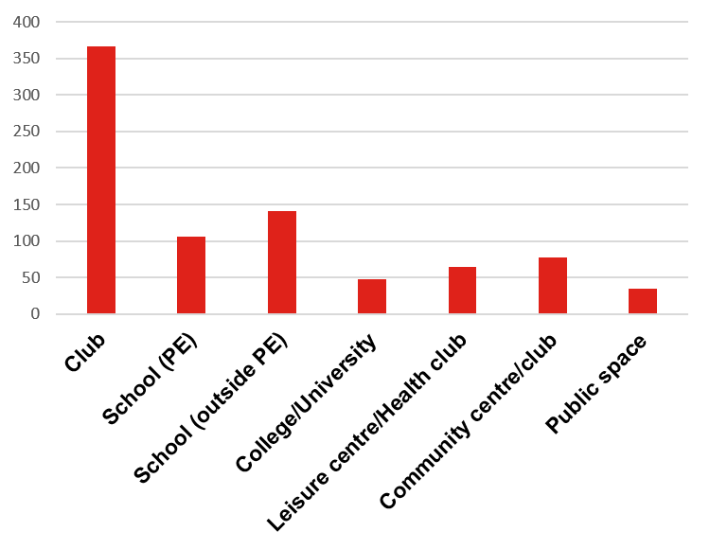
- 69% of coaches deliver in clubs.
- 20% of London’s coaches are delivering in school as part of PE lessons.
- 27% deliver in schools outside of PE.
- 9% deliver in colleges and/or universities.
- 45% of coaches are delivering in just one setting.
- Of the 367 coaches delivering in a club, 32% also coach in schools (outside of PE lessons).

Fig 5: Number of coaches delivering in each setting

What type of sessions are coaches delivering?
Coached sessions can broadly be divided into three categories:
- Participation (e.g. introductory sessions, targeting inactives)
- Performance (e.g. team training, for competition)
- Health (e.g. GP referral, weight loss)

Our responding coaches deliver across all three categories:
- 64% of coaches identify as delivering for performance
- 62% of coaches identify as delivering for participation
- 44% deliver both types of session, (20% deliver just performance, 18% just participation)
- 8% coaches identify as delivering for health
- 27% of coaches are also coaching on the talent pathway
When looking into the profiles of coaches based on the category of session they deliver (e.g. only delivering participation sessions) to see if there were discernible characteristics, no clear differences were noted between the performance coach, participation coach and those delivering both performance and participation. The data already included in this report is true for these coaches.

However, there are some slight differences for coaches delivering health sessions:
- 1/3 of these coaches are full-time (compared with 15% across London)
- 45% of these coaches are female (compared to 32% across London)
- The second biggest route into coaching for this group is volunteering, not as a parent/helper
- They are the only group for whom opportunity for personal development is a top three motivation for being a coach

Who is getting coached?
Research such as Understanding Women’s Lives (Women in Sport, 2013) and Under the Skin: Youth Personalities (Sport England, 2015) shows that participants have different motivations for taking part in sport and physical activity. These motivations can require different approaches to effectively engage and retain the participants. The most common reasons are:

- Enjoyment
- Keep fit
- Meet with friends
- Improve performance
- Train for competition
- Lose weight
- Parent/child activity
- Help with injury or disability

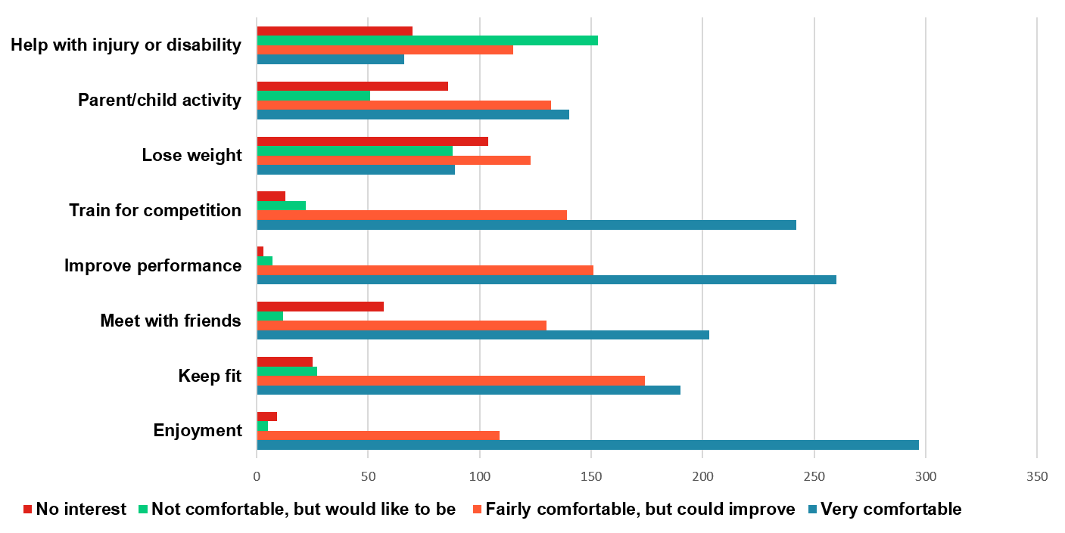
Fig 6: Self-identified ability to deliver a session aimed at each motivation

Confidence in the ability to coach groups with ‘train for competition’ and ‘improve performance’ motivations is high; this could be reflective of the current course content for sport specific coaching qualifications which are traditionally technically focused.

The health and social motivations (lose weight, keep fit and meet with friends) are less likely to be included in course content for formal coaching qualifications, and the lower ability and interest in coaching these motivations could be reflective of this exclusion from formal learning.

With many coaches indicating an interest in growing their skills to comfortably deliver sessions to help with injury or disability, parent and child activities, and losing weight, there is an implication for further training provision.

There continues to be lower level of participation in physical activity and sport around specific segments of the general population. As with motivations before, different groups may require different approaches to effectively engage them.

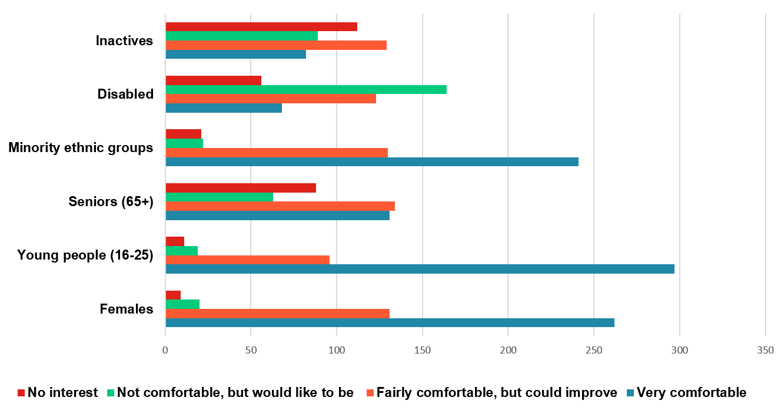
Fig 7: Self-identified ability to deliver sessions to target groups

In recent years, more work has been done to understand engagement and retention of women and young people in physical activity and sport which may be a precursor to higher levels of confidence in coaching these groups.

With a number of coaches indicating an interest in growing their skills and knowledge in delivering to disabled participants, inactive participants and senior participants, there is an argument for supporting coaches in these areas.

It is important to recognise that not all coaches want to coach all target groups, or deliver sessions that cater to all motivations. Just as engagement and retention of a participant relies on the session meeting their needs and expectations, a coach needs lead sessions that they find engaging. For coaches to be retained in coaching and provide high quality experiences to their audience, they need to be coaching in environments that appeal and to groups that inspire and interest them. This will impact on how and who is recruited to deliver in London.

Section 6: Growth of Delivery, Motivating People to Stay in Coaching

Motivating people to stay in coaching
London’s coaches are busy, and time is precious. When we asked the coaches how often they’d like to coach, 25% responded that they wanted to coach more often. What’s stopping them?

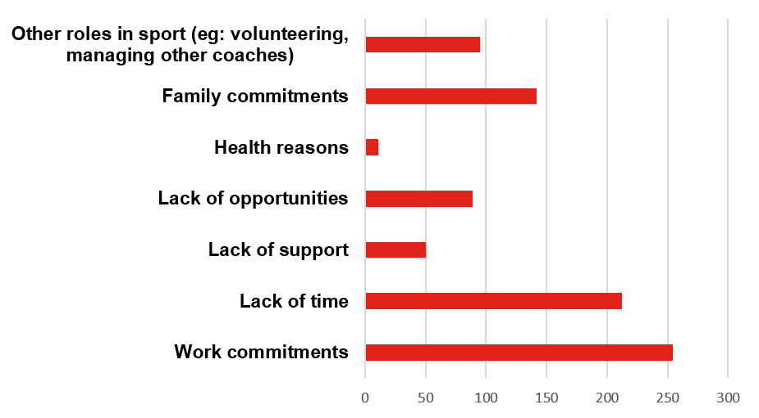
The three main reasons that stop coaches coaching more are:
- Work commitments.
- Lack of time.
- Family commitments.

However, coaches who would like to coach more highlight lack of opportunities as the main reason they aren’t coaching more.

Fig 8: Barriers to coaching more

Whilst gender doesn’t show different barriers to coaching more, the coach’s age does highlight different priorities in their day to day lives. This impacts on the amount of coaching they do. Work commitments and lack of time remain high for all age groups (pre-65+ years).

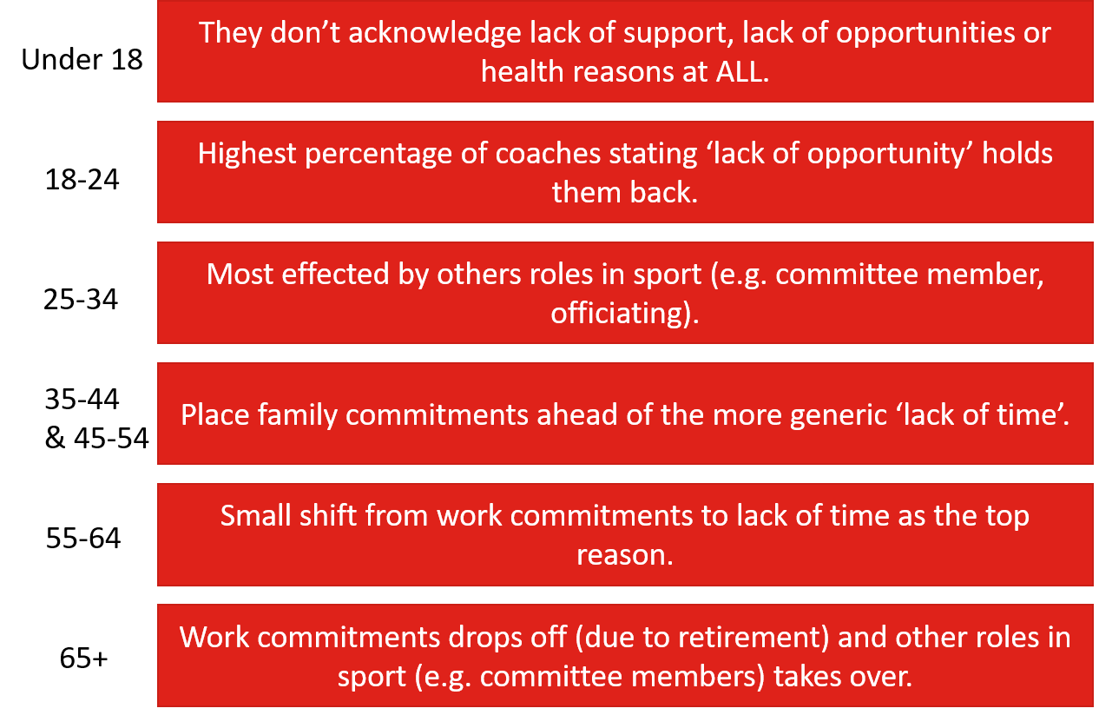

Fig 9: Main barriers to finding coaching opportunities

Coaches who would like to do more delivery are spread across London, with some actively interested in growing their coaching into new boroughs. The sample covers 33 different sports and although there is more interest in delivering in club and school settings, there are coaches looking to expand their delivery into leisure and community facilities and spaces.

Section 7: Training and Development

Qualification pathway
Survey respondents cover all levels of the coaching pathway, from holding no formal qualification in coaching through to Level 3 and above (or equivalent).

Level 2 (or equivalent) was the most common qualification with over 225 coaches holding this level of qualification.

In line with national data, the lower the qualification held the more likely they are to be ready to progress to the next qualification. Over half of all the Level 1, activator and no qualification coaches are ready to progress on the coaching pathway and approximately 40% of Level 2 and Level 3 or above coaches are ready to progress to the next level.

Continued Professional Development
Defined as methods that a coach employs to improve/deepen their knowledge, continued professional development can be formal (organised and structured presentation of learning to a coach) or informal (mentoring, talking to other coaches, searching the internet).

Source of Learning | Used in the last 12 months | Preferred method ranking
Talking to other coaches | 73% | 2nd
Observing/working with other coaches | 69% | 1st
Watching videos on the internet (you tube etc) | 62% | 7th
Reflecting on coaching sessions | 58% | 5th
Searching/using the internet | 58% | 8th
Feedback from athletes or players | 56% | 4th
Reading books | 45% | 11th
Coaching qualifications | 44% | 3rd
Other coaching workshops | 41% | 6th
Online learning courses | 35% | 8th
Mentoring | 29% | 11th
Social media (Twitter, Facebook, LinkedIn) | 29% | 15th
Coaching conferences | 26% | 10th
FE/HE Qualifications related to coaching or sport | 13% | 13th
Formal distance learning | 10% | 14th

Within the top ten methods of learning for coaches, only three are formal and these are ranked 8th, 9th and 10th in terms of being used in the last 12 months. When asked to mark their preferred method for learning, the top two methods remain consistent, but coaching qualifications moves into third place and other coaching workshops moved up to 6th, this implies that more formal learning is valued but not accessed every year.

How supported do coaches feel?
Overall, 85% of London’s coaches feel supported by their Local Authority, National Governing Body or London Sport. This is higher than the national data for 2015 (83%) but matches the national trend which showed an increase from 79% in 2014.

From national data, Sports Coach UK have highlighted that coaches that feel ‘supported a little’ are twice as likely to drop out of coaching than those identifying themselves as within any other category of support. National data has shown a shift of coaches since 2014 towards feeling more supported than the previous year.
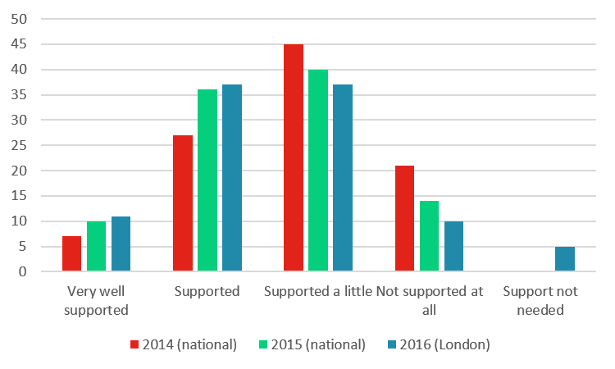
If we are to keep the existing workforce active, then focus needs to be on moving the coaches who feel ‘supported a little’ or ‘not at all’ along the scale to ‘supported’ and ‘very well supported’.

Fig 10: How supported coaches feel

Focus needs to be placed on the areas that these groups of coaches feel less supported in. Coaches who feel supported a little cited help with identifying education and development needs, and identifying development opportunities as their main issues. Whereas, coaches who felt not supported at all want help with the cost of development opportunities.

Section 8: Recommendations

We recognise that to support Londoners to be more active, the workforce must be both attractive for new people to enter and fulfilling enough for people to stay in it.

Create a bigger workforce:
- Look to recruit from the local community – creating a workforce that is more reflective of the population being encouraged to engage with activity.

- Work to recruit from professions with similar skills to those of a sports coach – our results show that careers in policing, teaching and those who have coaching/mentoring roles use these experiences to enhance their delivery.

Support the existing workforce:
- Improve support for finding opportunities to deliver
  - Better records of who holds qualifications, where they live and deliver, and if they are active or inactive coaches.

- Provide coaching opportunities that support the dual benefits of coaching
  - Understand what motivates each person to become a coach and ensure their coaching allows them to meet that need.
  - Include the motivational focus of a session in the role description when recruiting coaches to new posts, so they can make informed choices as to what meets their own values.

Develop a better workforce:
- Support coaches from non-sporting backgrounds by letting them learn alongside experienced coaches.

- Traditional courses should include softer skills alongside the technical modules., including:
  - Behaviour change
  - Understanding the participant’s motivations

- Develop a joined-up approach to continued professional development that brings together provision from specific governing bodies, general providers (e.g. Sports Coach UK), and specialist knowledge from London Sport that allows for cross-sport learning.

